

**Amazon AWS User Guide**

Contents

Introduction: 3

Resources: 3

Console: 4

phpMyAdmin: 7

EC2: 9

S3: 10

# Introduction:

This guide is meant to be used as a resource for administrators of SuperPoints. Within this guide, the administrator will be provided information on how to use the Amazon AWS console for the SuperPoints application.

Information provided in this document are retrieved from the AWS user guides, and additional information if necessary, can also be found on the website.

# Resources:

RDS: <https://docs.aws.amazon.com/AmazonRDS/latest/UserGuide/Welcome.html>

EC2: <https://docs.aws.amazon.com/AWSEC2/latest/UserGuide/concepts.html>

S3: <https://docs.aws.amazon.com/AmazonS3/latest/dev/Welcome.html>

# Console:

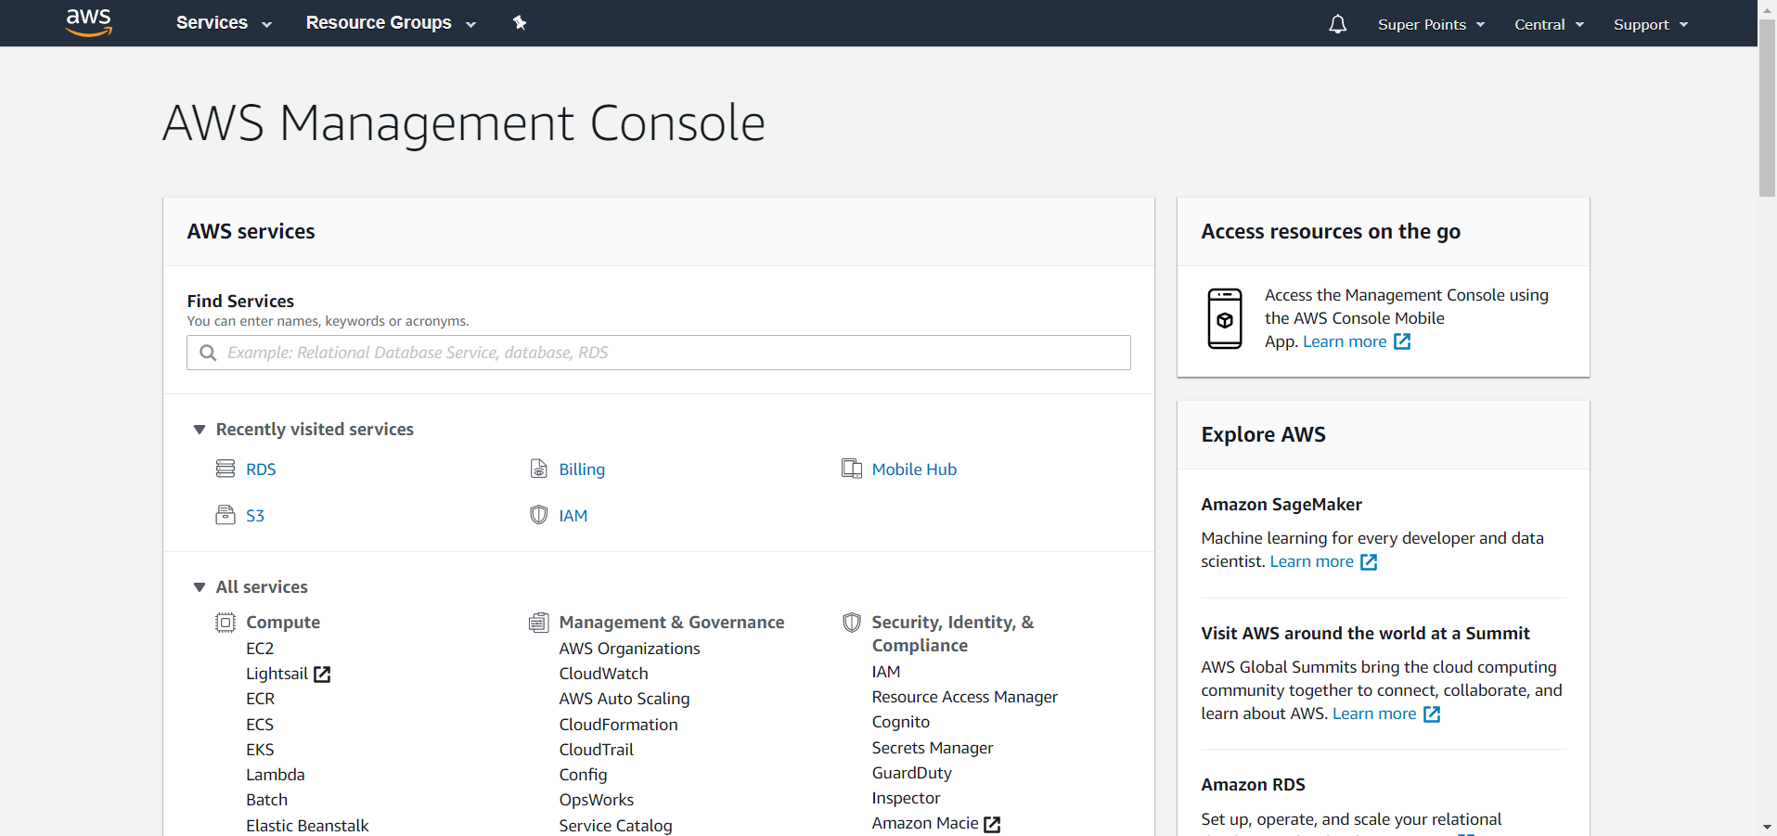

Upon logging in, you will be presented with the home screen of the AWS Management Console. If you click on the account name on the top right (highlighted by the red box), you will be given the options to view account details and billing information among others.

Scrolling down from the Console homepage will display all of Amazon AWS’ services. The services that we are using as of this guide are EC2, S3, and RDS.

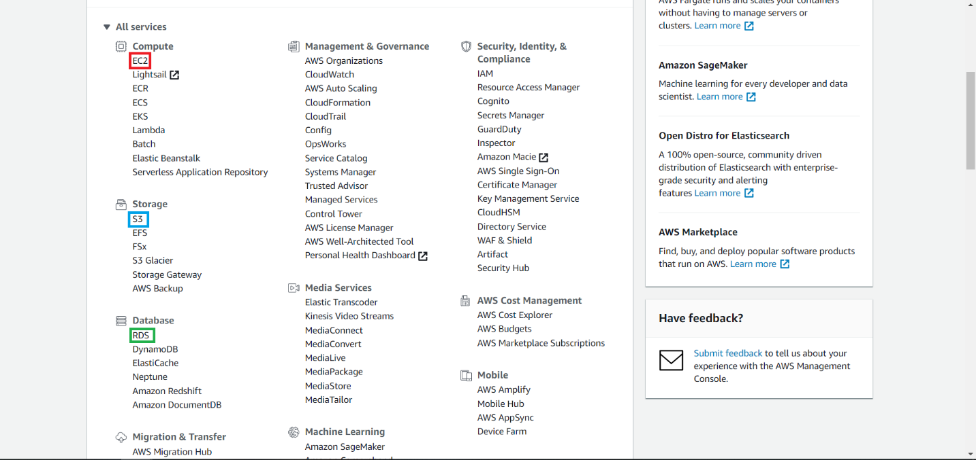

RDS:

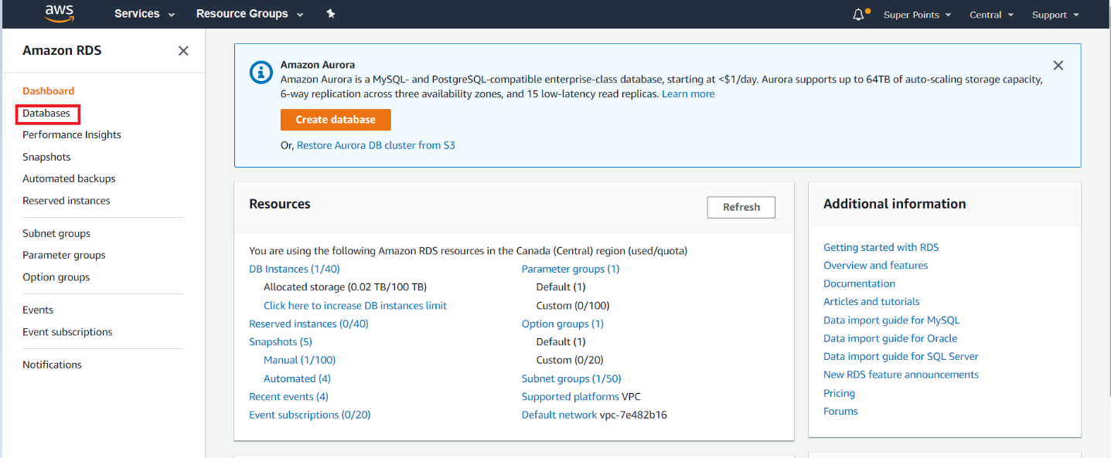Clicking on RDS link (as seen inside the green box in Figure 2) will redirect us to the RDS homepage, from here we can view all our databases. As of this document, we have only have one database. Clicking on the “Databases” link on the left of the screen will redirect us to the list of Databases. From there we can view our Databases and perform any actions necessary.

A brief overview of the database will be presented once we click on the “Databases” link. We can see the engine of the Database (MySQL), region, current size, and whether the database is active or not.

If we would like to modify the database, we should select the radio button next to the database in the small red box, then click “Modify” in the medium-sized red box. If we would like to see statistics about the database, for example the number of connections to the database, we should click on the name of the database as selected by the orange box.

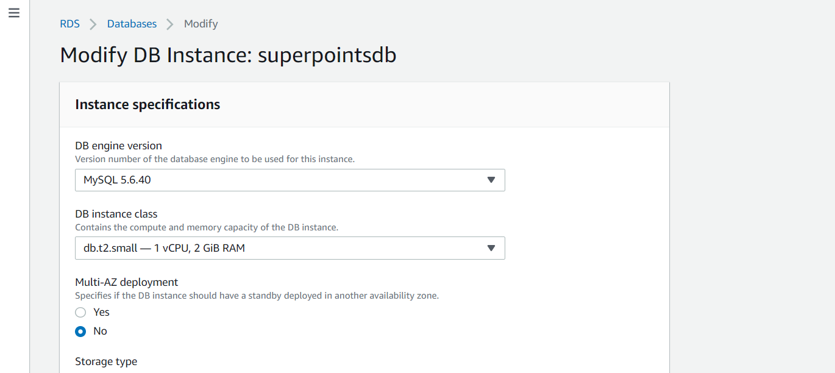As emphasis was placed on scalability, we will look into how we can easily scale the Database to match an increase in users. Once we have entered the page as directed by clicking on “Modify”, we will see that the first option is to specify the Instance specifications. From here, we may modify the MySQL version, but more importantly, we can scale the database up to deal with an increase of queries to the database.

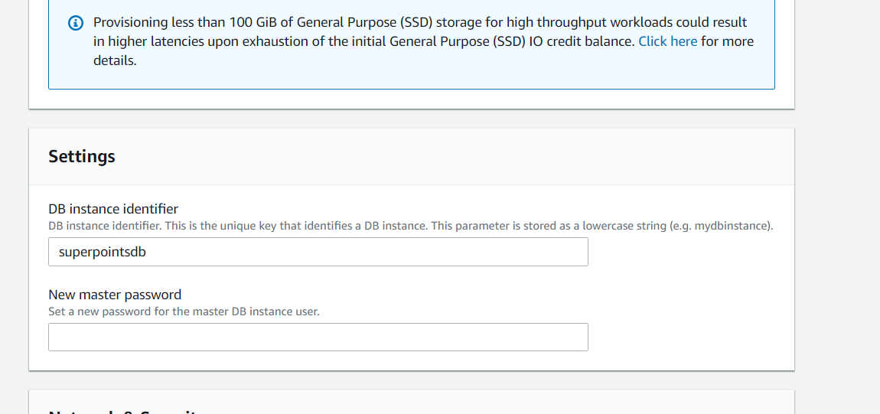Another point of interest would be modifying the master password for the database. This should not be done frequently, as this will also need be reflected in the script file for database operations.

# phpMyAdmin:

To access the database, we can use our webserver (which will be discussed in the next section) for visual access.

To access the database follow:   
<http://ec2-99-79-49-31.ca-central-1.compute.amazonaws.com/phpmyadmin/>

For credentials use the following:

Username: admin  
Password: zxcasdqwe123  
Server Choice: superpoints

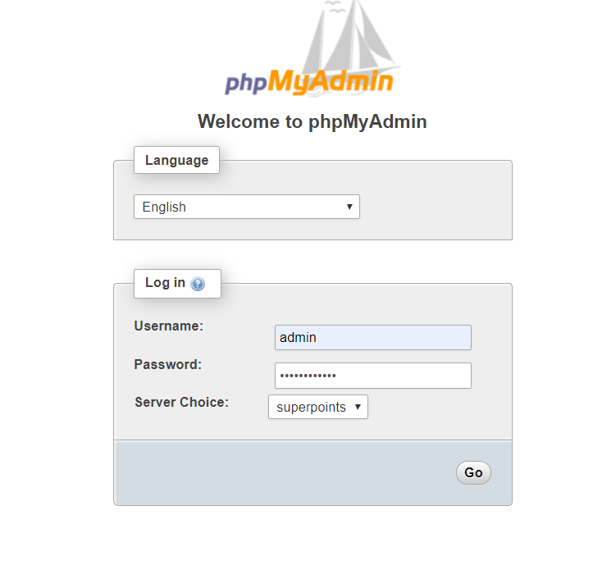

For some basic querying, for example, viewing all of the promotions inside the database, we can accomplish this by expanding “superpoints” on the left of the screen. Afterwards, click on “Promotions”, do not expand it.

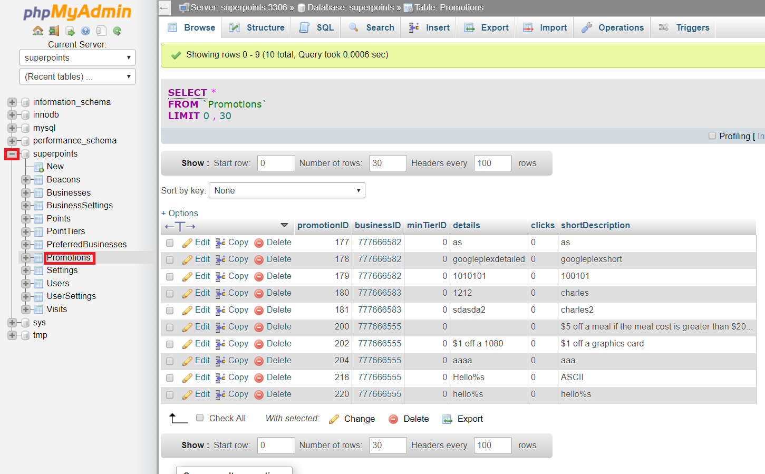

# EC2:

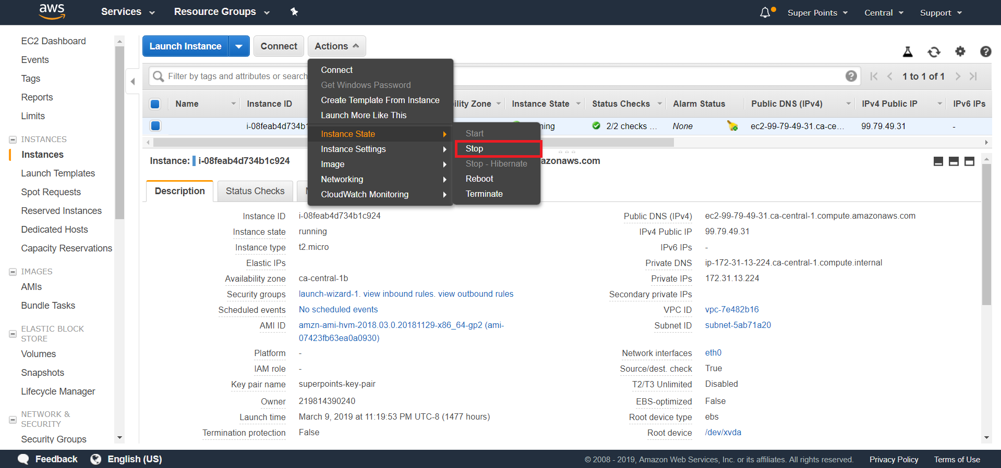Clicking on the red box will direct us to the EC2 dashboard. Click on the “Running Instances” link to view the host for the webserver.

To change the instance state to accommodate an influx of users, we will need to stop the instance first.

1. Click on “Actions”
2. Hover over “Instance State”
3. Select “Stop”

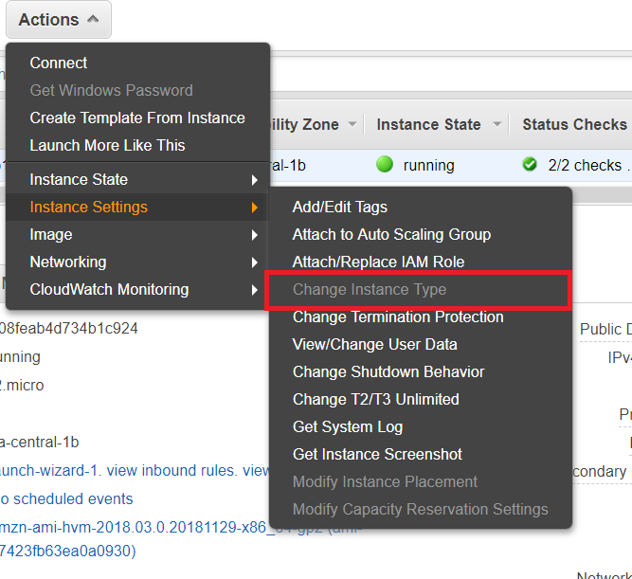Afterwards, click on “Actions” again, except this time hover over “Instance Settings”. This will show us an option to change the Instance Type.

To obtain access to the EC2 server, you will need to generate a key pair. As this is primarily for a developer, we will only provide brief steps.

The first step to gaining access to the EC2 server is generating a key-pair.

Follow this guide: <https://docs.aws.amazon.com/AWSEC2/latest/UserGuide/ec2-key-pairs.html#having-ec2-create-your-key-pair> to generate the key-pair.

Next, we will need to decide on a method to connect to the Linux instance. The following methods can be found listed on: <https://docs.aws.amazon.com/AWSEC2/latest/UserGuide/AccessingInstances.html>

An easy way to connect to the instance is through PuTTY. To find documentation on that, click on “Connecting to Your Linux Instance from Windows Using PuTTY” in the previous link.

# S3:

Clicking on the S3 link will redirect you to the dashboard for S3. S3 is primarily used to store images used when a business user creates a promotion.

S3 is a storage service, and does not have an option to increase scalability.

One use case of the S3 dashboard however, is to view the image of a promotion directly on the website.

To do so, do the following:

1. Select “[superpoints-userfiles-mobilehub-467637819](https://s3.console.aws.amazon.com/s3/)”
2. Select “promo”
3. Find the promotion id of the promotion image you wish to find  
   (To find the promotion id, follow the phpMyAdmin guide from above and explore the Promotions table)
4. Click on the item with the corresponding item.   
   Depending on whether you clicked on the name of the image or not, you will be directed to another page with more options, or simply have a quick description of the object on the right side of the screen.
5. Follow the link specified by the Object URL